Equatorial Diameter
# Source: AI Source: Provided by: [Data Path: Persons Table -> ID Column: 1, Name_En Column: Motasem Essam] -> From: [ChatGPT] on [7/25/2026]
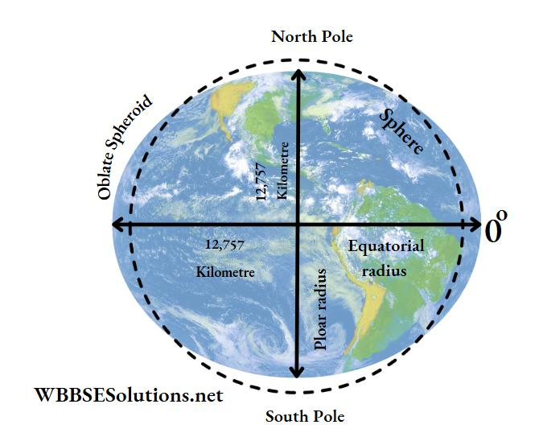
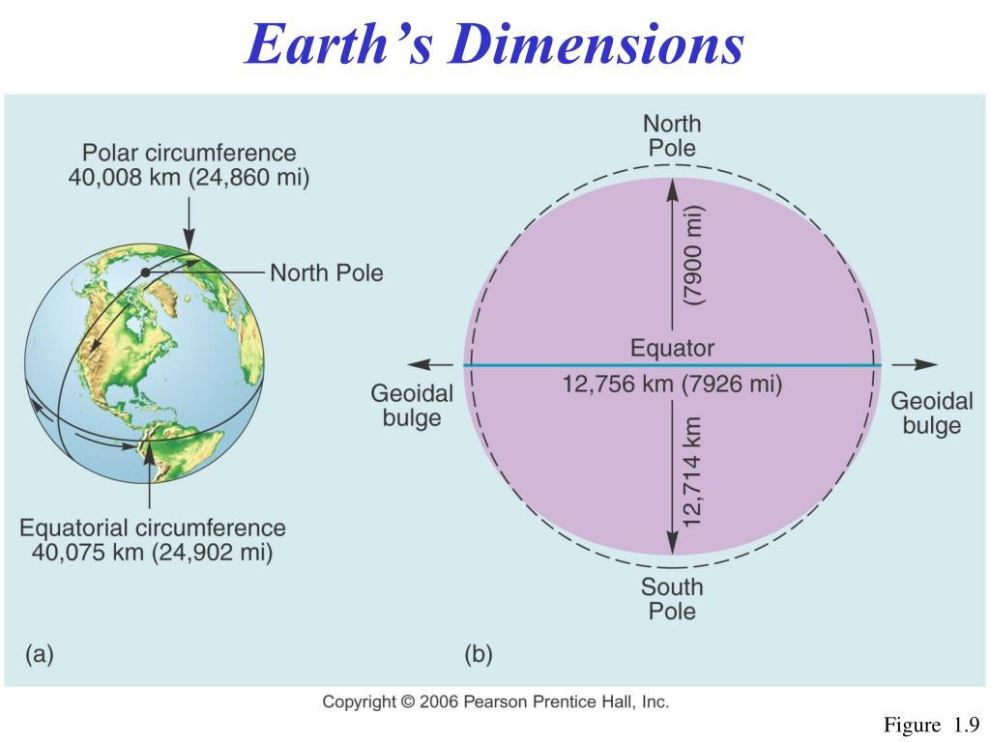
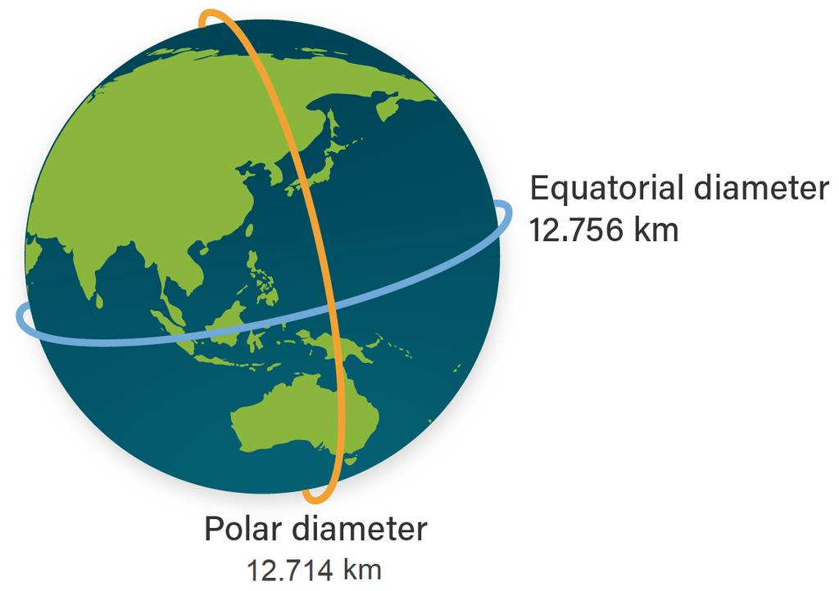
7

Definition
# Source: AI Source: Provided by: [Data Path: Persons Table -> ID Column: 1, Name_En Column: Motasem Essam] -> From: [ChatGPT] on [7/25/2026]
The equatorial diameter is a diameter measured through the center of a sphere or sphere-like body in the direction of its equator. For a body with a defined polar axis, it lies in the equatorial plane, which passes through the center and is perpendicular to that axis.
For a perfect sphere, every diameter has the same length, so the equatorial diameter equals the polar diameter. For an oblate spheroid, such as an idealized model of Earth, the equatorial diameter is longer than the polar diameter.

Simple Definition
# Source: AI Source: Provided by: [Data Path: Persons Table -> ID Column: 1, Name_En Column: Motasem Essam] -> From: [ChatGPT] on [7/25/2026]
The equatorial diameter is the straight-line distance from one side of a spherical body to the opposite side, passing through its center along the equatorial direction.

Geometric Representation
# Source: AI Source: Provided by: [Data Path: Persons Table -> ID Column: 1, Name_En Column: Motasem Essam] -> From: [ChatGPT] on [7/25/2026]
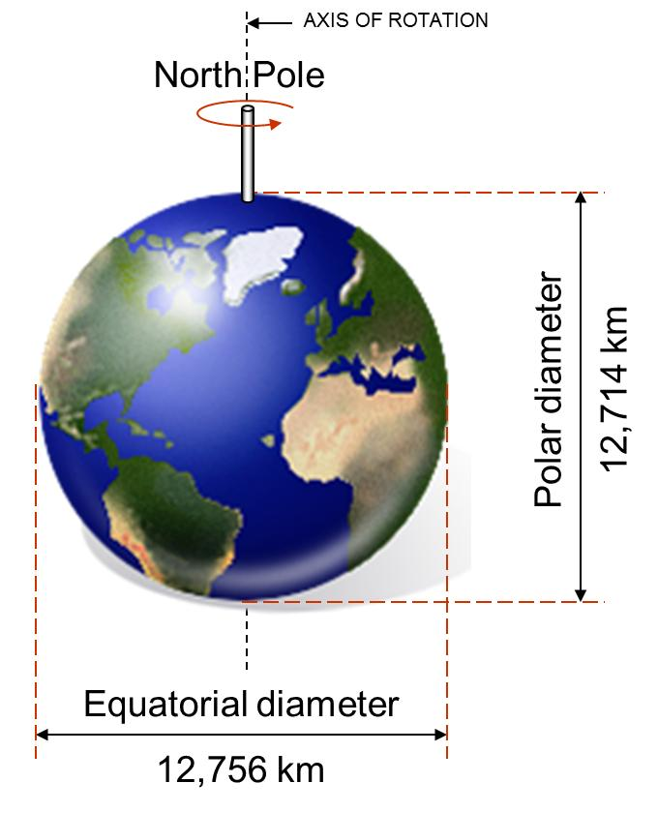
The main parts are:
- Equatorial plane: The plane through the center perpendicular to the polar axis.
- Equatorial radius ($R_{e}$): The distance from the center to the equator.
- Equatorial diameter ($D_{e}$): The full diameter across the body in the equatorial direction.
- Polar axis: The axis connecting the two poles in a body with defined poles.
The equatorial diameter is twice the equatorial radius.
$$\boxed{D_{e}=2R_{e}}$$
Where:
- $D_{e}$ = equatorial diameter
- $R_{e}$ = equatorial radius

Types According to the Shape of the Body
# Source: AI Source: Provided by: [Data Path: Persons Table -> ID Column: 1, Name_En Column: Motasem Essam] -> From: [ChatGPT] on [7/25/2026]
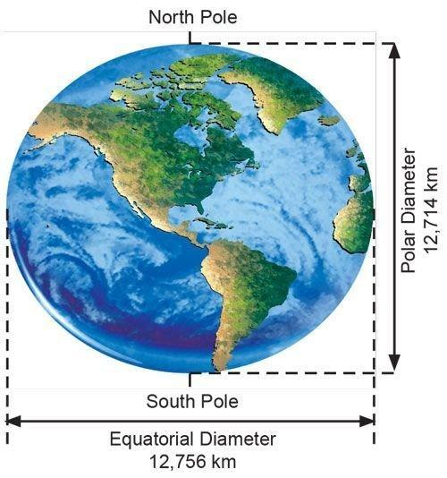

Equatorial Diameter of a Perfect Sphere
# Source: AI Source: Provided by: [Data Path: Persons Table -> ID Column: 1, Name_En Column: Motasem Essam] -> From: [ChatGPT] on [7/25/2026]
All diameters have equal lengths regardless of direction.
$$D_{e}=D_{p}=2R$$

Equatorial Diameter of an Oblate Spheroid
# Source: AI Source: Provided by: [Data Path: Persons Table -> ID Column: 1, Name_En Column: Motasem Essam] -> From: [ChatGPT] on [7/25/2026]
The body is flattened at its poles and wider around its equator.
$$D_{e}>D_{p}$$
Example: Earth's approximate shape.
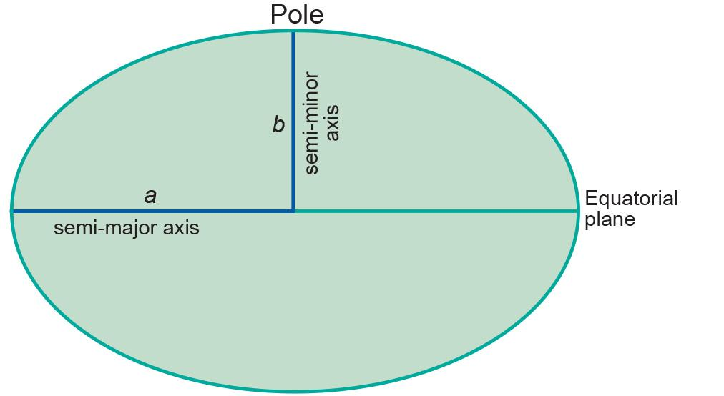

Equatorial Diameter of a Prolate Spheroid
# Source: AI Source: Provided by: [Data Path: Persons Table -> ID Column: 1, Name_En Column: Motasem Essam] -> From: [ChatGPT] on [7/25/2026]
The body is elongated along its polar axis, making the equatorial diameter shorter than the polar diameter.
$$D_{e}<D_{p}$$

Key Characteristics
# Source: AI Source: Provided by: [Data Path: Persons Table -> ID Column: 1, Name_En Column: Motasem Essam] -> From: [ChatGPT] on [7/25/2026]
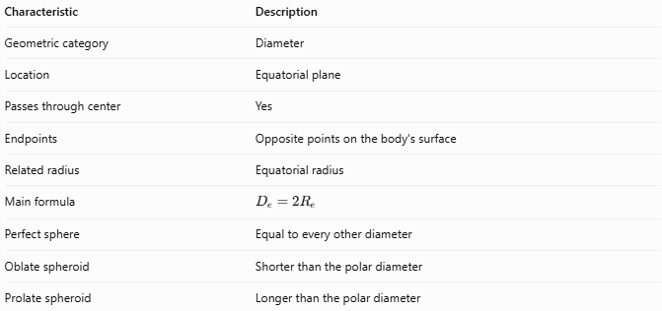
Characteristic | Description
Geometric category | Diameter
Location | Equatorial plane
Passes through center | Yes
Endpoints | Opposite points on the body's surface
Related radius | Equatorial radius
Main formula | $$D_{e}=2R_{e}$$
Perfect sphere | Equal to every other diameter
Oblate spheroid | Shorter than the polar diameter
Prolate spheroid | Longer than the polar diameter

Mathematical Formulas

Equatorial diameter
# Source: AI Source: Provided by: [Data Path: Persons Table -> ID Column: 1, Name_En Column: Motasem Essam] -> From: [ChatGPT] on [7/25/2026]
$$\boxed{D_{e}=2R_{e}}$$

Equatorial radius
# Source: AI Source: Provided by: [Data Path: Persons Table -> ID Column: 1, Name_En Column: Motasem Essam] -> From: [ChatGPT] on [7/25/2026]
$$\boxed{R_{e}=\frac{D_{e}}{2}}$$

Circumference of the equatorial circle
# Source: AI Source: Provided by: [Data Path: Persons Table -> ID Column: 1, Name_En Column: Motasem Essam] -> From: [ChatGPT] on [7/25/2026]
For the circle formed where the equatorial plane intersects the body:
$$\boxed{C_{e}=πD_{e}=2πR_{e}}$$

Area of the equatorial circular cross-section
# Source: AI Source: Provided by: [Data Path: Persons Table -> ID Column: 1, Name_En Column: Motasem Essam] -> From: [ChatGPT] on [7/25/2026]
$$\boxed{A_{e}=πR_{e}^{2}=\frac{πD_{e}^{2}}{4}}$$
This is the area of the equatorial disk, not the total surface area of the sphere or spheroid.

6.5. Comparison with polar diameter
# Source: AI Source: Provided by: [Data Path: Persons Table -> ID Column: 1, Name_En Column: Motasem Essam] -> From: [ChatGPT] on [7/25/2026]
$$\boxed{ΔD=D_{e}-D_{p}}$$
Here, $ΔD$ is the difference between equatorial and polar diameters. It is positive for an oblate spheroid, zero for a perfect sphere, and negative for a prolate spheroid.

Worked Examples
# Source: AI Source: Provided by: [Data Path: Persons Table -> ID Column: 1, Name_En Column: Motasem Essam] -> From: [ChatGPT] on [7/25/2026]
Example 1 — Calculate the Equatorial Diameter
Given: Equatorial radius $R_{e}=8\text{ cm}$.
Formula:
$$D_{e}=2R_{e}$$
Calculation:
$$D_{e}=2\left(8\right)=16\text{ cm}$$
Answer: The equatorial diameter is 16 cm.
Example 2 — Calculate the Equatorial Radius
Given: Equatorial diameter $D_{e}=30\text{ m}$.
$$R_{e}=\frac{D_{e}}{2}=\frac{30}{2}$$
Answer: The equatorial radius is 15 m.
Example 3 — Compare Equatorial and Polar Diameters
Given:
- Equatorial diameter: $D_{e}=100\text{ cm}$
- Polar diameter: $D_{p}=96\text{ cm}$
Calculate the difference:
$$ΔD=100-96=4\text{ cm}$$
Answer: The equatorial diameter is 4 cm longer than the polar diameter, indicating an oblate shape under this model.
Example 4 — Earth's Approximate Equatorial Diameter
Using the WGS84 reference ellipsoid:
- Equatorial radius: $R_{e}=6,378.137\text{ km}$
- Polar radius: $R_{p}=6,356.752\text{ km}$, approximately
The equatorial diameter is:
$$D_{e}=2\left(6,378.137\right)$$
$$\boxed{D_{e}=12,756.274\text{ km}}$$
This is a reference-ellipsoid value; Earth's actual surface is not a perfect mathematical spheroid.

Equatorial Diameter vs. Related Concepts
# Source: AI Source: Provided by: [Data Path: Persons Table -> ID Column: 1, Name_En Column: Motasem Essam] -> From: [ChatGPT] on [7/25/2026]
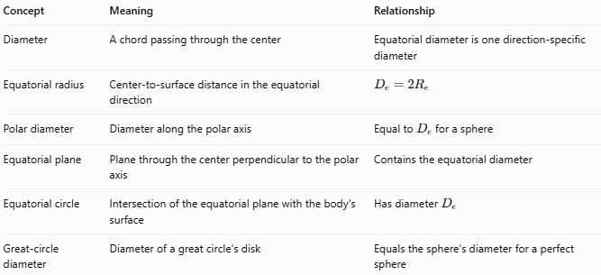
Concept | Meaning | Relationship
Diameter | A chord passing through the center | Equatorial diameter is one direction-specific diameter
Equatorial radius | Center-to-surface distance in the equatorial direction | $$D_{e}=2R_{e}$$
Polar diameter | Diameter along the polar axis | Equal to $D_{e}$ for a sphere
Equatorial plane | Plane through the center perpendicular to the polar axis | Contains the equatorial diameter
Equatorial circle | Intersection of the equatorial plane with the body's surface | Has diameter $D_{e}$
Great-circle diameter | Diameter of a great circle's disk | Equals the sphere's diameter for a perfect sphere

Applications
# Source: AI Source: Provided by: [Data Path: Persons Table -> ID Column: 1, Name_En Column: Motasem Essam] -> From: [ChatGPT] on [7/25/2026]
- Astronomy: Comparing the dimensions of planets, stars, and other celestial bodies.
- Geography and geodesy: Describing Earth's dimensions using a reference ellipsoid.
- Mathematics: Studying spheroids and comparing directional dimensions.
- Engineering: Specifying dimensions of spherical or spheroidal components.
- Physics: Modeling rotating bodies whose dimensions differ along and perpendicular to their rotation axes.

Key Points
# Source: AI Source: Provided by: [Data Path: Persons Table -> ID Column: 1, Name_En Column: Motasem Essam] -> From: [ChatGPT] on [7/25/2026]
- The equatorial diameter passes through the center in the equatorial direction.
- It is twice the equatorial radius: $D_{e}=2R_{e}$.
- A perfect sphere has equal equatorial and polar diameters.
- An oblate spheroid has a longer equatorial diameter than polar diameter.
- A prolate spheroid has a shorter equatorial diameter than polar diameter.
- The equatorial diameter should not be confused with the circumference of the equatorial circle.

Conclusion
# Source: AI Source: Provided by: [Data Path: Persons Table -> ID Column: 1, Name_En Column: Motasem Essam] -> From: [ChatGPT] on [7/25/2026]
The equatorial diameter describes the width of a sphere or sphere-like body across its equatorial direction. It is a fundamental measurement for distinguishing a perfect sphere from spheroidal shapes and for describing the dimensions of celestial bodies such as Earth.

